# Supplementary materials

## Predicting Crop Yields and Soil-Plant Nitrogen Dynamics in the US Corn Belt

**Table S1:** Experimental details for the 94 location-year-crop-management trials

**Table S2:** Soil profile characteristics for the 10 experimental locations

**Table S3:** Weather information by year, location and month

**Table S4:** Average water table values per experimental location used in modeling

**Table S5:** Changes to APSIM maize crop model parameters

**Table S6:** Changes to APSIM soybean crop model parameters

**Table S7:** Variable names, categories and range of values used in the sensitivity analysis

**Figure S1:** Water table map for the US Midwest

**Figure S2:** Workflow of the in-season forecast

**Figure S3:** Example of LAI and biomass in-season forecast

**Figure S4:** Weather uncertainty in yield prediction by location

**Figure S5:** Sensitivity analysis additional variables

**Figure S6:** Simulated yields and root depths with and without water table

**Figure S7:** Maize root depth

**Figure S8:** Maize leaf number

**Figure S9:** Maize leaf area index

**Figure S10:** Maize biomass accumulation

**Figure S11:** Maize grain accumulation

**Figure S12:** Maize leaf N concentration

**Figure S13:** Maize plant N uptake

**Figure S14:** Maize grain N uptake

**Figure S15:** Soybean root depth

**Figure S16:** Soybean leaf number

**Figure S17:** Soybean leaf area index

**Figure S18:** Soybean biomass accumulation

**Figure S19:** Soybean grain accumulation

**Figure S20:** Soybean leaf N concentration

**Figure S21:** Soybean plant N uptake

**Figure S22:** Soybean grain N uptake

**Figure S23:** Soil moisture

**Figure S24:** Soil temperature

**Figure S25:** Soil nitrate

**Figure S26:** Soil water table depth







|  |  |
| --- | --- |
| **Table S4**: Average depth of the water table per location used in the model to drive the bottom boundary condition. | |
| Location | Average depth to water table (cm) |
| Northwest Iowa – Sutherland | 120 |
| Northcentral Iowa – Kanawha | 125 |
| Northeast Iowa – Nashua | 140 |
| Central Iowa – Boone | 130 |
| Central Iowa – Boone2 | 130 |
| Central Iowa – Kelley | 115 |
| Southwest Iowa – Lewis | 230 |
| Southcentral Iowa – McNay | 130 |
| Southeast Iowa – Crawfordsville | 125 |
| Southwest Iowa – Muscatine | –a |
| a: a free drainage bottom boundary condition was used in this location | |

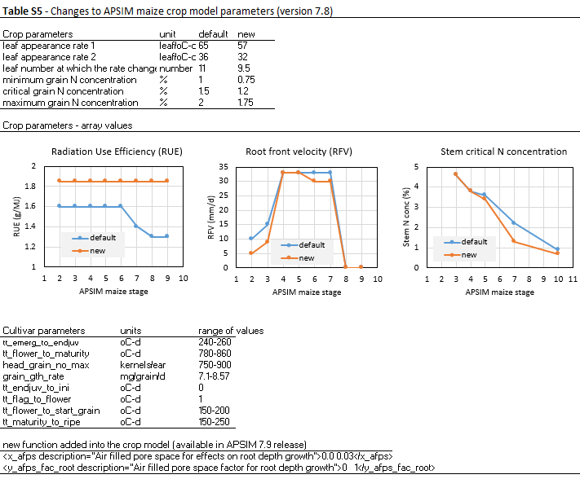

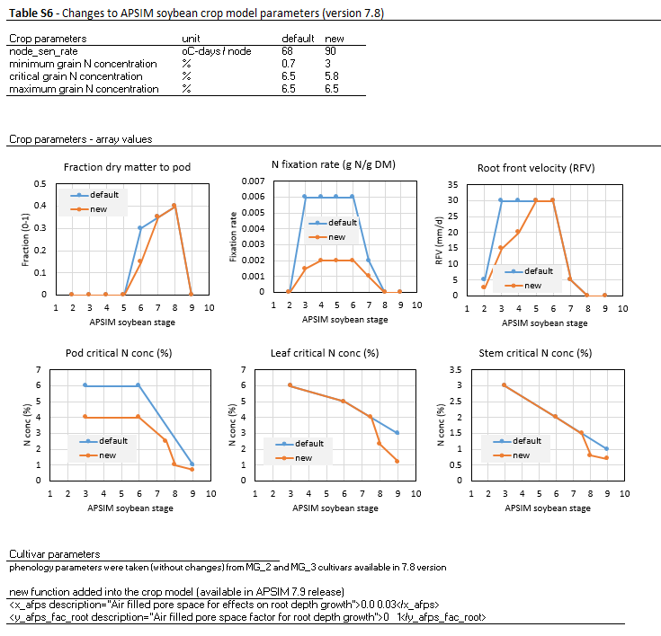



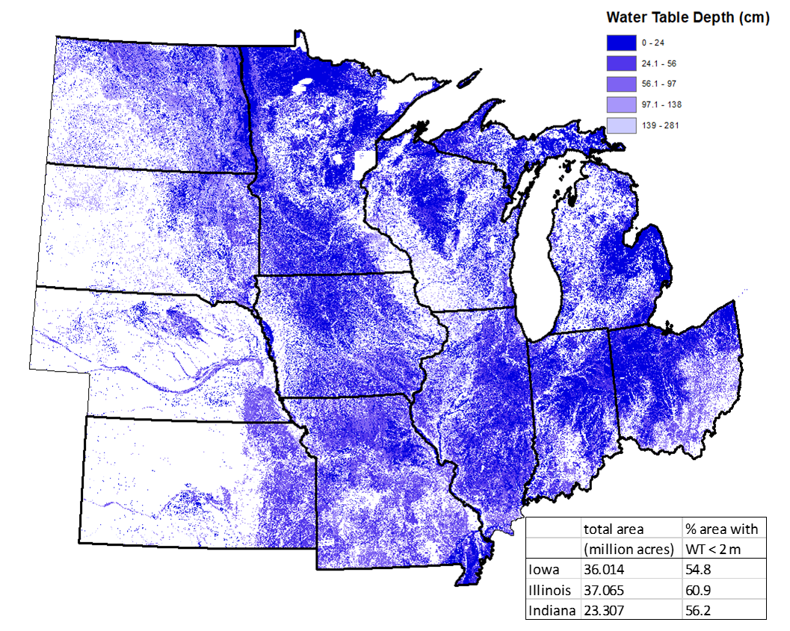

**Figure S1:** Depth to water table from soil surface in cm. Data are presented at 1 km2 spatial resolution. Source: SSURGO (Soil Survey Staff, 2019)

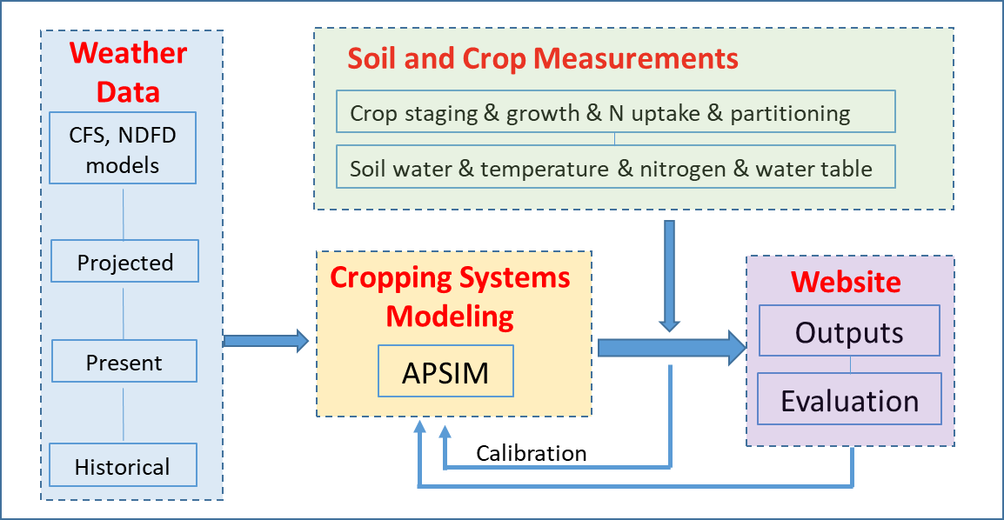

**Figure S2:** Workflow of the in-season forecast

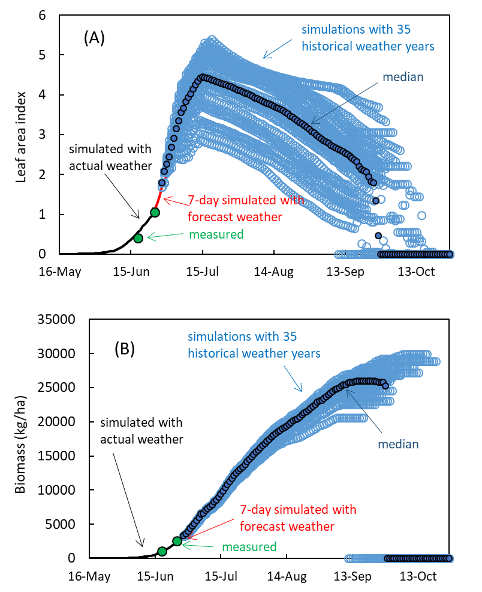

**Figure S3:** In season prediction of leaf area index (panel A) and biomass production (panel B) on June 26, 2016. Each panel illustrates measured data, simulated data using actual weather, predicted data using 7-day forecasted weather, predicted using a range of historical data and the median predicted value. This information was publically available via <https://crops.extension.iastate.edu/facts/> and was updated every 10 days. Data from the central Iowa, Kelley location, maize crop, year 2016 are displayed in the above panels (see also Table S1, ID=10).

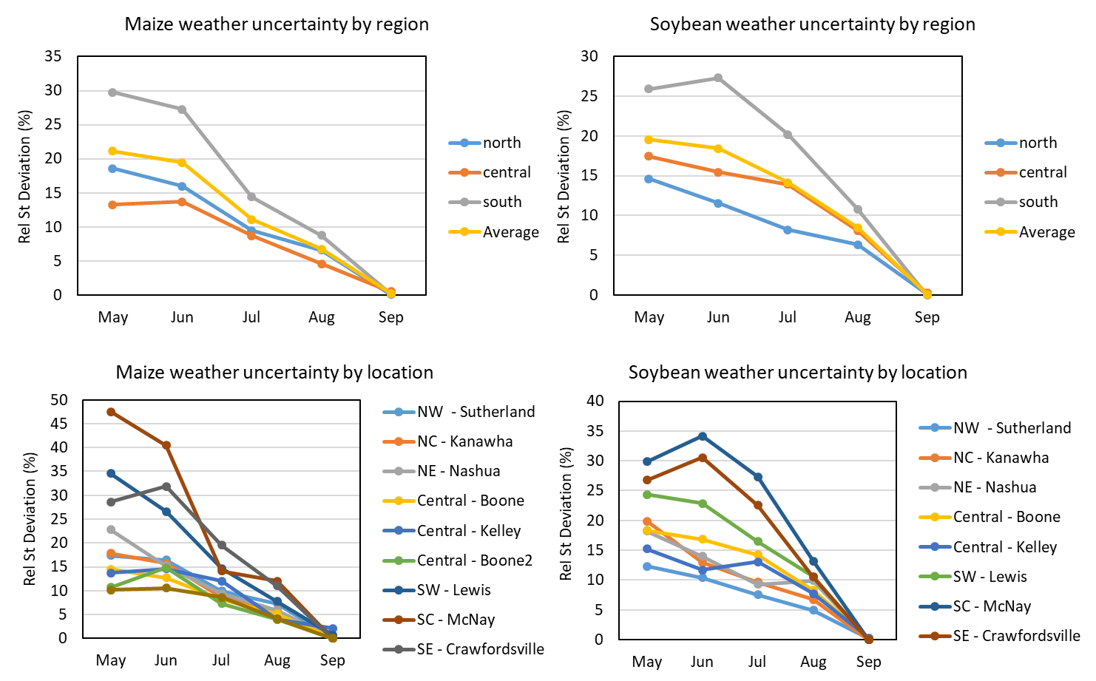

**Figure S4:** Weather uncertainty in yield predictions by crop and by region or location across all years.

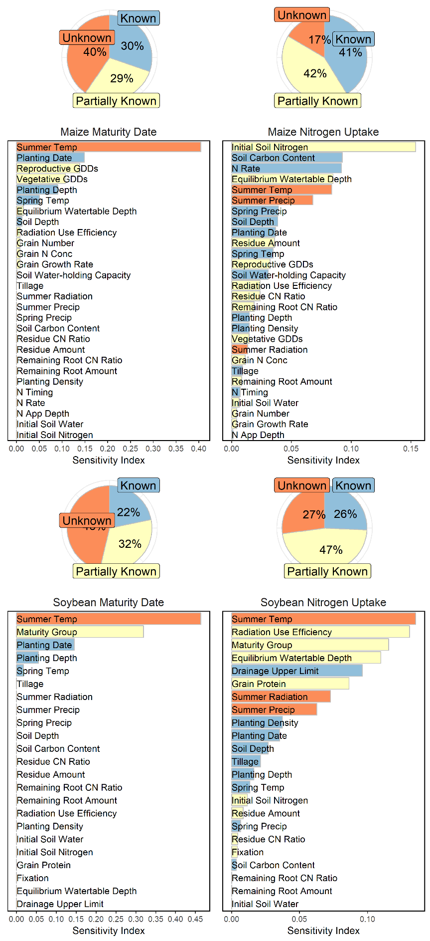

**Figure S5:** Sensitivity analysis of maize and soybean nitrogen uptake and physiological maturity.

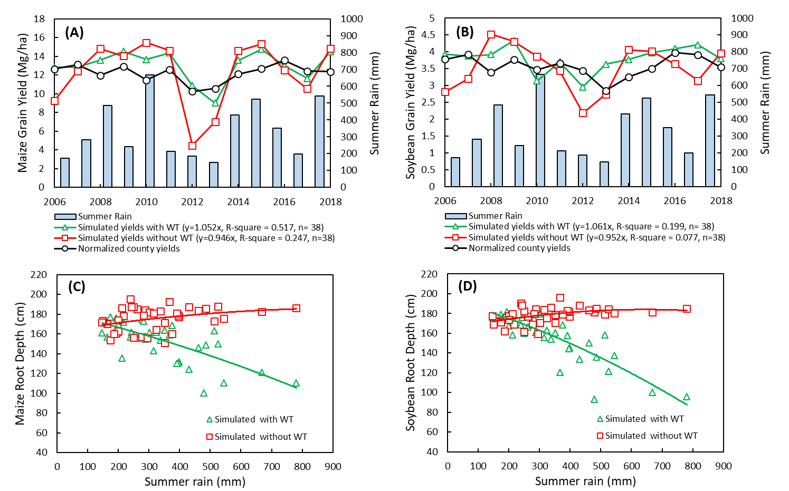

**Figure S6:** Simulated (1980-2018) yield and root depths with and without water table in central Iowa. Normalized (genetic and management effects were removed from the 1980-2018 period) NASS maize and soybean yields for the Boone county, Iowa are also included for comparison.

